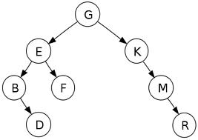
Basic Definition of Binary Tree

- Father Node: G is the father node
- Leaf Nodes: D, R are the leaf nodes
- Ancestor: G is the ancestor of E & K
- Descendent: E is the left descendent and K is the right descendent
- Siblings: B & F are the siblings of E
- Degree : Number of nodes connected to a particular node

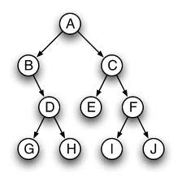
Strictly Binary Tree
jhhhhuhuhu
Level 0
Level 1
Level 2
Level 3

  - Hight of a tree: max level of tree + 1

Propertise of a Binary Tree
- A tree with n nodes has exactly (n-1) edges or branches.
- Maximum no. of of nodes in a binary tree on level i is 2^{i} , i >= 0
- Maximum no. of nodes in a binary tree of height h is (2^{h} - 1) , h >= 1
- Full Binary Tree of height h, having (2^{h} - 1) nodes, h >= 0
- Every node of Extended Binary Tree has 0 or 2 children, is also called 2-tree

